Housing Pricing

With the fluctuating real estate market, understanding the factors influencing housing prices is crucial for buyers, sellers, and investors. The Housing Pricing project aims to explore how various features such as area, number of bedrooms, bathrooms, presence of amenities like air conditioning, and location attributes (e.g., main road access, preferred areas) impact the price of housing. We'll examine data from the Housing Prices Dataset, focusing on a selection of 545 housing listings with detailed attributes.

# Questions:

1. How do different features of a house (size, number of bedrooms/bathrooms, etc.) affect its price?

2. Is there a significant difference in price based on the presence of certain amenities (air conditioning, hot water heating, etc.)?

3. How do location-based attributes (being on a main road, in a preferred area) influence the housing price?

# Hypothesis:

1. Larger area, higher number of bedrooms and bathrooms, and the presence of amenities like air conditioning positively influence the housing price.

2. Houses in preferred areas and those with access to a main road command higher prices.

3. The furnishing status of a house (furnished, semi-furnished, unfurnished) significantly impacts its sale price.

# Data Analysis Approach:

The project will involve:

1. Importing and cleaning the Housing Pricing Dataset.
2. Renaming columns for clarity and consistency.
3. Conducting exploratory data analysis to understand the distribution of prices and other features.
4. Using statistical models to assess the impact of various factors on housing prices.
5. Visualizing the findings to highlight key insights on what drives housing prices.

By analyzing these aspects, the Housing Pricing Project aims to provide valuable insights into the housing market, supporting better decision-making for stakeholders involved in real estate transactions.

# Step 4: Visualization

## Correlation Analysis

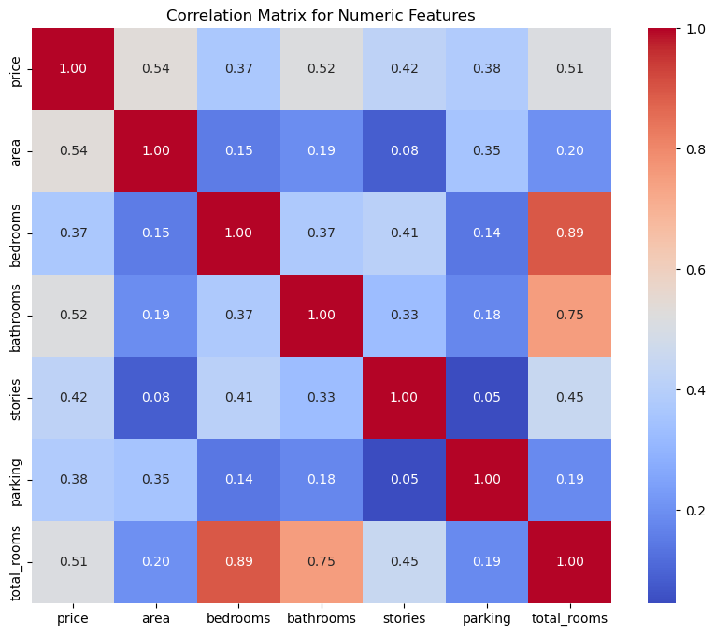

Area and Price: A correlation coefficient of 0.536 suggests a moderate positive relationship between the area of the house and its price. Larger houses tend to be priced higher.

Bedrooms/Total Rooms and Price: Both bedrooms and total rooms have a positive correlation with price (0.366 and 0.512, respectively), indicating that more rooms generally correspond to a higher price.

Bathrooms and Price: With a correlation coefficient of 0.518, the number of bathrooms has a moderate positive correlation with price, suggesting houses with more bathrooms tend to be more expensive.)

## Scatter Plots

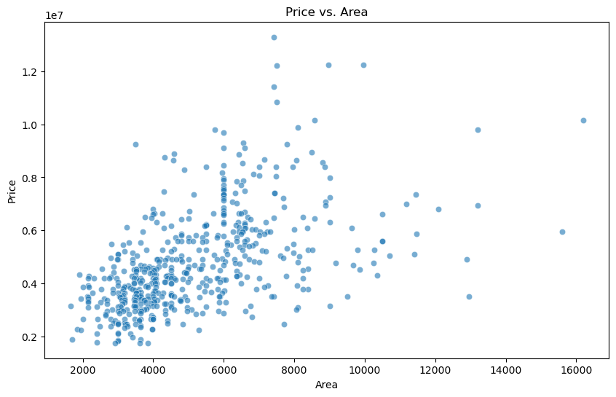

Based on the "Price vs. Area", it appears there's a positive relationship between the area of a property and its price. As the area increases, the price also tends to increase, although the relationship does not seem to be perfectly linear and there's considerable variability in price within similar area ranges. This suggests that while area is an important factor in determining price, there are likely other factors at play that also significantly affect the price of a property. The spread of data points indicates there may be a moderate positive correlation between area and price.

## 

## Bar Charts

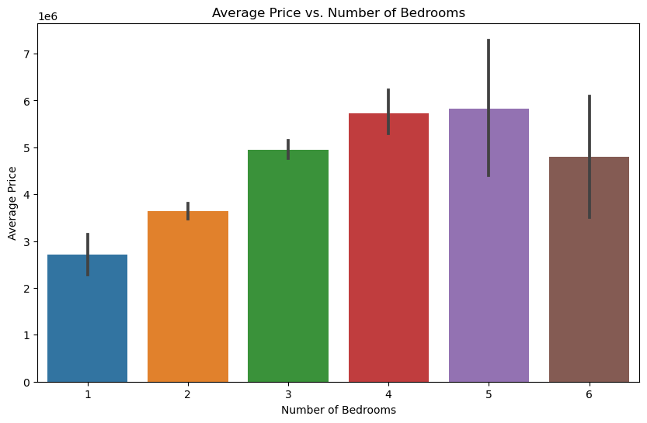

Price Peak: The peak of the average price is at 4 bedrooms, which suggests that 4-bedroom houses, on average, are the most expensive in the dataset. This might be due to 4-bedroom homes being the most sought-after, or possibly because they are more likely to have additional desirable features.

Variability: The error bars (the black lines on top of each bar) indicate the variability or the standard deviation of the prices within each bedroom category. A larger error bar means there is more variation in the prices of houses with that number of bedrooms. For example, 5 and 6 bedroom houses show substantial variability in price.

Decrease for Larger Homes: There's a noticeable decrease in average price for houses with 5 and 6 bedrooms compared to 4 bedrooms. This could suggest that less common configurations (like 5 or 6 bedrooms) may not add the same value as the more common 3 or 4-bedroom homes, or it could indicate a smaller sample size for these categories, leading to

less reliable average price indications.)

## 

## 

## 

## 

## Box Plots

### # Box plot for air conditioning and water heating

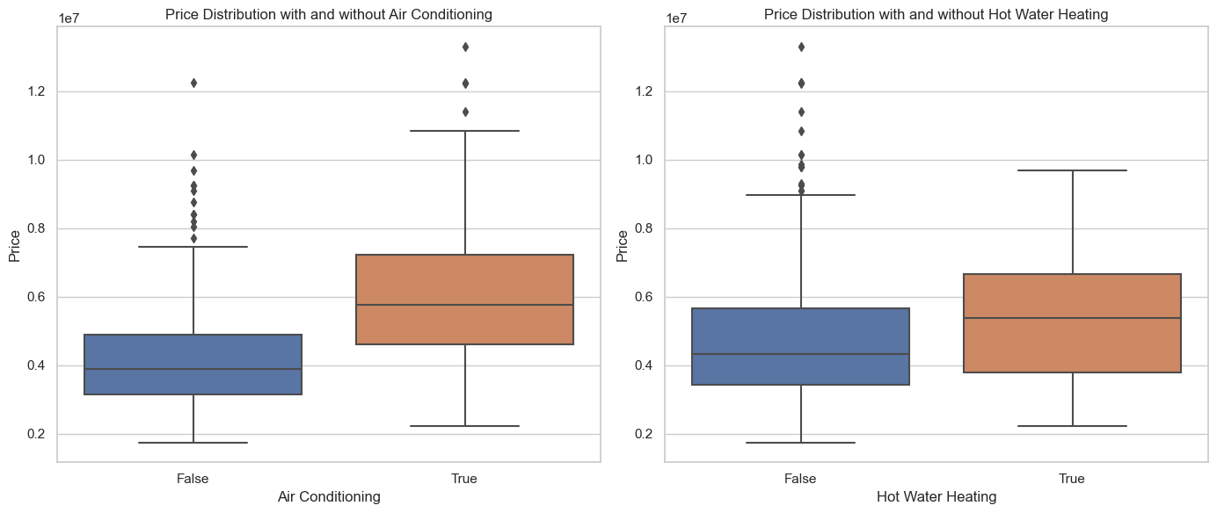

Air Conditioning: There appears to be a significant difference in price between houses with air conditioning and those without. Houses with air conditioning tend to have higher median prices and a wider range of prices, indicating that air conditioning is likely a valued amenity influencing housing prices.

Hot Water Heating:Similarly, there's a noticeable difference in price distribution between houses with and without hot water heating. Although the number of houses with hot water heating might be smaller (indicated by the narrower interquartile range), these houses tend to have a higher median price, suggesting that hot water heating is also an amenity that could positively affect housing prices.

These insights suggest that the presence of these amenities does indeed have a significant impact on the prices of houses.

### # Box plot for furnishing status

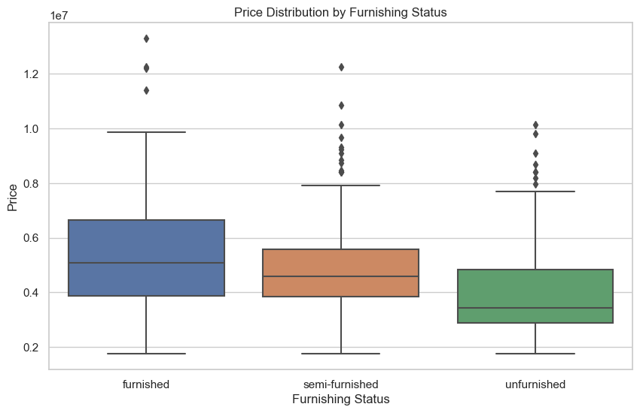

Furnished: houses tend to have a higher median price compared to semi-furnished and unfurnished houses. This suggests that furnishing is an important factor that buyers consider and are willing to pay a premium for.

Semi-Furnished: houses have a median price that is slightly lower than furnished houses but higher than unfurnished houses. The spread of prices in semi-furnished houses is also quite wide, indicating a varied market.

Unfurnished: houses have the lowest median price among the three categories. This could indicate that buyers might be looking for a lower entry price or prefer to furnish the house according to their taste, which affects their willingness to pay.

This analysis shows that the furnishing status of a house significantly impacts its price, with furnished houses generally fetching higher prices in the market.

### # Box plot for houses on a main road and in a preferred area

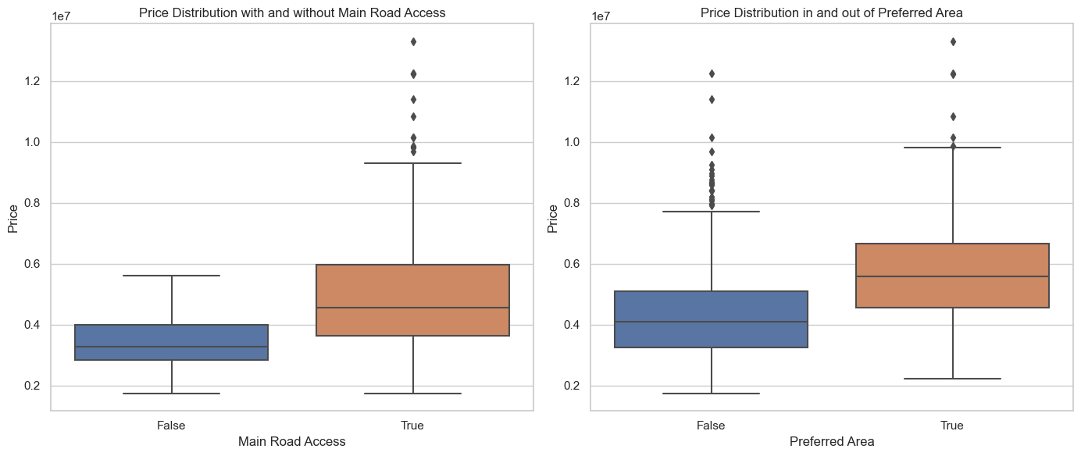

Main Road Access: There's a noticeable difference in the price distribution between houses with and without main road access. Houses with access to a main road generally have higher median prices, indicating that this feature could be a significant factor in determining housing prices.

Preferred Area: The difference in price distributions is even more pronounced for houses in preferred areas compared to those outside. Houses located in preferred areas have substantially higher median prices and a wider price range, suggesting that being in a preferred area is a highly valued attribute that positively influences housing prices.

These insights suggest that both being on a main road and being in a preferred area are influential factors in the pricing of houses.

# Answers to questions:

1. **How do different features of a house (size, number of bedrooms/bathrooms, etc.) affect its price?**

The price of a house is significantly influenced by its size, number of bedrooms, and area. Four-bedroom houses tend to be the most expensive, indicating a peak demand for this size. However, the price variability increases for houses with more than four bedrooms. Moreover, there's a positive correlation between the house's area and its price, suggesting larger properties generally cost more, though this relationship is influenced by other factors as well.

1. **Is there a significant difference in price based on the presence of certain amenities (air conditioning, hot water heating, etc.)?**

Yes, there is a significant difference in price based on the presence of certain amenities such as air conditioning and hot water heating. Houses with air conditioning tend to have higher median prices and a wider price range, suggesting that air conditioning is a valued amenity. Similarly, houses with hot water heating also show a higher median price, although the number of such houses might be smaller, indicating that hot water heating is considered a positive feature by buyers. These amenities significantly impact housing prices, highlighting their importance in the real estate market.

1. **How do location-based attributes (being on a main road, in a preferred area) influence the housing price?**

Location-based attributes like being on a main road and being in a preferred area significantly influence housing prices. Houses with main road access generally command higher median prices, indicating the value of accessibility and convenience this feature provides. Similarly, houses located in preferred areas see even more pronounced price distinctions, with substantially higher median prices and a wider price range. This suggests that being in a preferred area is a highly valued characteristic, likely due to factors such as better neighborhood quality, proximity to amenities, and desirability, which all contribute positively to housing prices.